# Four Routes Calling Implement Experiment

## Introduction

The digital I / O ports indicate the INPUT and OUTPUT interfaces. In the previous LED experiment, we only used the OUTPUT function of GPIO. Now let us try to use the INPUT function of I/O in Raspberry Pi, that is the function is to read the output value from an external device in this experiment. We use buttons and LEDs to complete the experiment using INPUT and OUTPUT as a combination.

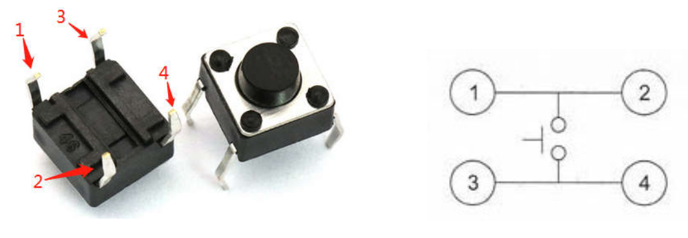

Button structure diagram

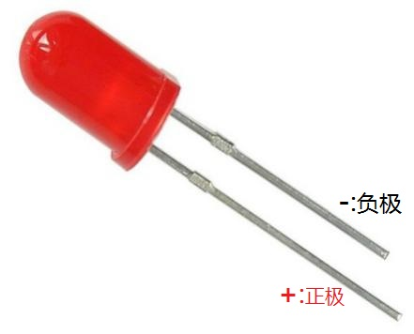 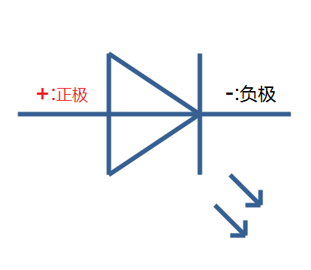

LED structure diagram

## Experimental purpose

For example, we want to hold a knowledge contest, so we use LEDs as a simple answering device. The basic principle of this experiment is that once the answer button is pressed, the circuit of this LED will be turned on, then it will be lit and the LED circuits of other groups will be cut off, so as to ensure that while the first person presses the button, the other people press the button is invalid.

**Component list**

* Raspberry Pi main board
* Raspberry Pi expansion board
* LED *4（red、yellow、green、blue）
* Button *4
* 1K Resistor *8
* Breadboard
* Several jumper wires

## Experimental wiring diagram

|  |  |
| --- | --- |
| LED | Raspberry Pi |
| Redled（+） | IO1(wiringPi)/18(BCM) |
| Buleled（+） | IO24(wiringPi)/19(BCM) |
| Greenled（+ ) | IO28(wiringPi)/20(BCM) |
| Yellowled ( + ) | IO29(wiringPi)/21(BCM) |
| Button1 | IO3(wiringPi)/22(BCM) |
| Button2 | IO4(wiringPi)/23(BCM) |
| Button3 | IO5(wiringPi)/24(BCM) |
| Button4 | IO6(wiringPi)/25(BCM) |

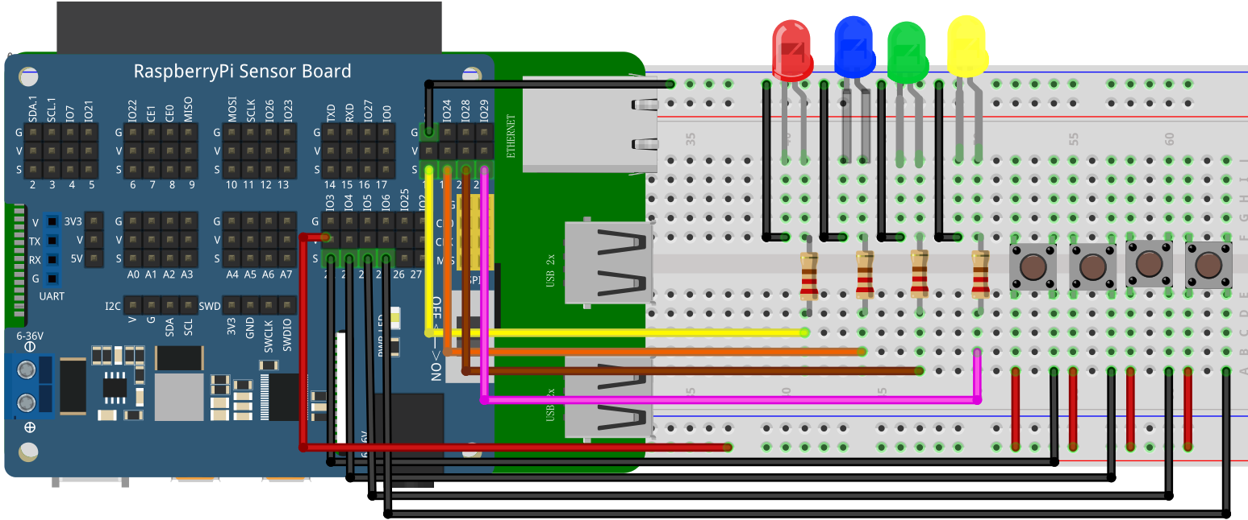

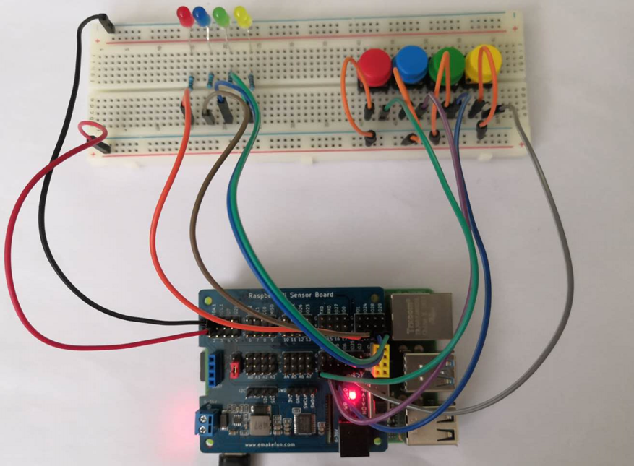

## C++ program

|  |
| --- |
| #include <wiringPi.h>  #include <stdio.h>  #define BtnPin_1 3  #define LEDpin_1 1  #define BtnPin_2 4  #define LEDpin_2 24  #define BtnPin_3 5  #define LEDpin_3 28  #define BtnPin_4 6  #define LEDpin_4 29  int main**(**void**)**  **{**  **if(**wiringPiSetup**()** **==** **-**1**){** //when initialize wiring failed,print messageto screen  printf**(**"setup wiringPi failed !"**);**  **return** 1**;**  **}**  pinMode**(**BtnPin_1**,** INPUT**);**  pinMode**(**LEDpin_1**,** OUTPUT**);**  pinMode**(**BtnPin_2**,** INPUT**);**  pinMode**(**LEDpin_2**,** OUTPUT**);**  pinMode**(**BtnPin_3**,** INPUT**);**  pinMode**(**LEDpin_3**,** OUTPUT**);**  pinMode**(**BtnPin_4**,** INPUT**);**  pinMode**(**LEDpin_4**,** OUTPUT**);**  **while(**1**)**  **{**  **if(**1 **==** digitalRead**(**BtnPin_1**))**  **{**  delay**(**20**);**  **while(**digitalRead**(**BtnPin_1**))**  **{**  digitalWrite**(**LEDpin_1**,** HIGH**);**  **}**  digitalWrite**(**LEDpin_1**,** LOW**);**  **}**  **if(**1 **==** digitalRead**(**BtnPin_2**))**  **{**  delay**(**20**);**  **while(**digitalRead**(**BtnPin_2**))**  **{**  digitalWrite**(**LEDpin_2**,** HIGH**);**  **}**  digitalWrite**(**LEDpin_2**,** LOW**);**  **}**    **if(**1 **==** digitalRead**(**BtnPin_3**))**  **{**  delay**(**20**);**  **while(**digitalRead**(**BtnPin_3**))**  **{**  digitalWrite**(**LEDpin_3**,** HIGH**);**  **}**  digitalWrite**(**LEDpin_3**,** LOW**);**  **}**  **if(**1 **==** digitalRead**(**BtnPin_4**))**  **{**  delay**(**20**);**  **while(**digitalRead**(**BtnPin_4**))**  **{**  digitalWrite**(**LEDpin_4**,** HIGH**);**  **}**  digitalWrite**(**LEDpin_4**,** LOW**);**  **}**  digitalWrite**(**LEDpin_1**,** LOW**);**  digitalWrite**(**LEDpin_2**,** LOW**);**  digitalWrite**(**LEDpin_3**,** LOW**);**  digitalWrite**(**LEDpin_4**,** LOW**);**  **}**  **return** 0**;**  **}** |

## Python program

|  |
| --- |
| import RPi**.**GPIO as GPIO  import time  BtnPin_1 **=** 22  LEDpin_1 **=** 18  BtnPin_2 **=** 23  LEDpin_2 **=** 19  BtnPin_3 **=** 24  LEDpin_3 **=** 20  BtnPin_4 **=** 25  LEDpin_4 **=** 21  GPIO**.**setmode**(**GPIO**.**BCM**)**  GPIO**.**setup**(**LEDpin_1**,** GPIO**.**OUT**)**  GPIO**.**setup**(**BtnPin_1**,** GPIO**.**IN**)**  GPIO**.**setup**(**LEDpin_2**,** GPIO**.**OUT**)**  GPIO**.**setup**(**BtnPin_2**,** GPIO**.**IN**)**  GPIO**.**setup**(**LEDpin_3**,** GPIO**.**OUT**)**  GPIO**.**setup**(**BtnPin_3**,** GPIO**.**IN**)**  GPIO**.**setup**(**LEDpin_4**,** GPIO**.**OUT**)**  GPIO**.**setup**(**BtnPin_4**,** GPIO**.**IN**)**  GPIO**.**output**(**LEDpin_1**,** GPIO**.**LOW**)**  GPIO**.**output**(**LEDpin_2**,** GPIO**.**LOW**)**  GPIO**.**output**(**LEDpin_3**,** GPIO**.**LOW**)**  GPIO**.**output**(**LEDpin_4**,** GPIO**.**LOW**)**  **while** True**:**  **if** GPIO**.**input**(**BtnPin_1**):**  time**.**sleep**(**0.04**)**  **while** GPIO**.**input**(**BtnPin_1**):**  GPIO**.**output**(**LEDpin_1**,** GPIO**.**HIGH**)**  GPIO**.**output**(**LEDpin_2**,** GPIO**.**LOW**)**  GPIO**.**output**(**LEDpin_3**,** GPIO**.**LOW**)**  GPIO**.**output**(**LEDpin_4**,** GPIO**.**LOW**)**  **if** GPIO**.**input**(**BtnPin_2**):**  time**.**sleep**(**0.04**)**  **while** GPIO**.**input**(**BtnPin_2**):**  GPIO**.**output**(**LEDpin_2**,** GPIO**.**HIGH**)**  GPIO**.**output**(**LEDpin_1**,** GPIO**.**LOW**)**  GPIO**.**output**(**LEDpin_3**,** GPIO**.**LOW**)**  GPIO**.**output**(**LEDpin_4**,** GPIO**.**LOW**)**  **if** GPIO**.**input**(**BtnPin_3**):**  time**.**sleep**(**0.04**)**  **while** GPIO**.**input**(**BtnPin_3**):**  GPIO**.**output**(**LEDpin_3**,** GPIO**.**HIGH**)**  **if** GPIO**.**input**(**BtnPin_4**):**  time**.**sleep**(**0.04**)**  **while** GPIO**.**input**(**BtnPin_4**):**  GPIO**.**output**(**LEDpin_4**,** GPIO**.**HIGH**)**  GPIO**.**output**(**LEDpin_1**,** GPIO**.**LOW**)**  GPIO**.**output**(**LEDpin_2**,** GPIO**.**LOW**)**  GPIO**.**output**(**LEDpin_3**,** GPIO**.**LOW**)**  GPIO**.**output**(**LEDpin_1**,** GPIO**.**LOW**)**  GPIO**.**output**(**LEDpin_2**,** GPIO**.**LOW**)**  GPIO**.**output**(**LEDpin_3**,** GPIO**.**LOW**)**  GPIO**.**output**(**LEDpin_4**,** GPIO**.**LOW**)**  GPIO**.**cleanup**()** |

## Java program

|  |
| --- |
| **import** com**.**pi4j**.**wiringpi**.**Gpio**;**  public class Button **{**  static int BtnPin_1 **=** 1**,** LEDpin_1 **=** 4**,** BtnPin_2 **=** 24**,** LEDpin_2 **=** 5**,** BtnPin_3 **=** 28**,** LEDpin_3 **=** 6**,** BtnPin_4 **=** 29**,** LEDpin_4 **=** 25**;**    static **{**  **if** **(**Gpio**.**wiringPiSetup**()** **==** **-**1**)** **{**  System**.**out**.**println**(**" ==>> GPIO SETUP FAILED"**);**  **}**    Gpio**.**pinMode**(**BtnPin_1**,** Gpio**.**INPUT**);**  Gpio**.**pinMode**(**LEDpin_1**,** Gpio**.**OUTPUT**);**  Gpio**.**pinMode**(**BtnPin_2**,** Gpio**.**INPUT**);**  Gpio**.**pinMode**(**LEDpin_2**,** Gpio**.**OUTPUT**);**  Gpio**.**pinMode**(**BtnPin_3**,** Gpio**.**INPUT**);**  Gpio**.**pinMode**(**LEDpin_3**,** Gpio**.**OUTPUT**);**  Gpio**.**pinMode**(**BtnPin_4**,** Gpio**.**INPUT**);**  Gpio**.**pinMode**(**LEDpin_4**,** Gpio**.**OUTPUT**);**  Gpio**.**digitalWrite**(**LEDpin_1**,** Gpio**.**HIGH**);**  Gpio**.**digitalWrite**(**LEDpin_2**,** Gpio**.**HIGH**);**  Gpio**.**digitalWrite**(**LEDpin_3**,** Gpio**.**HIGH**);**  Gpio**.**digitalWrite**(**LEDpin_4**,** Gpio**.**HIGH**);**  **}**  public static void main**(**String args**[])** **{**  **while** **(true)**  **{**  **if(!(**Gpio**.**digitalRead**(**BtnPin_1**)** **==** 1**))**  **{**  Gpio**.**delay**(**20**);**  **while(!(**Gpio**.**digitalRead**(**BtnPin_1**)** **==** 1**))**  **{**  Gpio**.**digitalWrite**(**LEDpin_1**,**Gpio**.**LOW **);**  **}**  Gpio**.**digitalWrite**(**LEDpin_1**,**Gpio**.**HIGH **);**  **}**    **if(!(**Gpio**.**digitalRead**(**BtnPin_2**)** **==** 1**))**  **{**  Gpio**.**delay**(**20**);**  **while(!(**Gpio**.**digitalRead**(**BtnPin_2**)** **==** 1**))**  **{**  Gpio**.**digitalWrite**(**LEDpin_2**,**Gpio**.**LOW **);**  **}**  Gpio**.**digitalWrite**(**LEDpin_2**,**Gpio**.**HIGH **);**  **}**    **if(!(**Gpio**.**digitalRead**(**BtnPin_3**)** **==** 1**))**  **{**  Gpio**.**delay**(**20**);**  **while(!(**Gpio**.**digitalRead**(**BtnPin_3**)** **==** 1**))**  **{**  Gpio**.**digitalWrite**(**LEDpin_3**,**Gpio**.**LOW **);**  **}**  Gpio**.**digitalWrite**(**LEDpin_3**,**Gpio**.**HIGH **);**  **}**    **if(!(**Gpio**.**digitalRead**(**BtnPin_4**)** **==** 1**))**  **{**  Gpio**.**delay**(**20**);**  **while(!(**Gpio**.**digitalRead**(**BtnPin_4**)** **==** 1**))**  **{**  Gpio**.**digitalWrite**(**LEDpin_4**,**Gpio**.**LOW **);**  **}**  Gpio**.**digitalWrite**(**LEDpin_4**,**Gpio**.**HIGH **);**  **}**  **}**  **}**  **}** |

## Experimental Effect

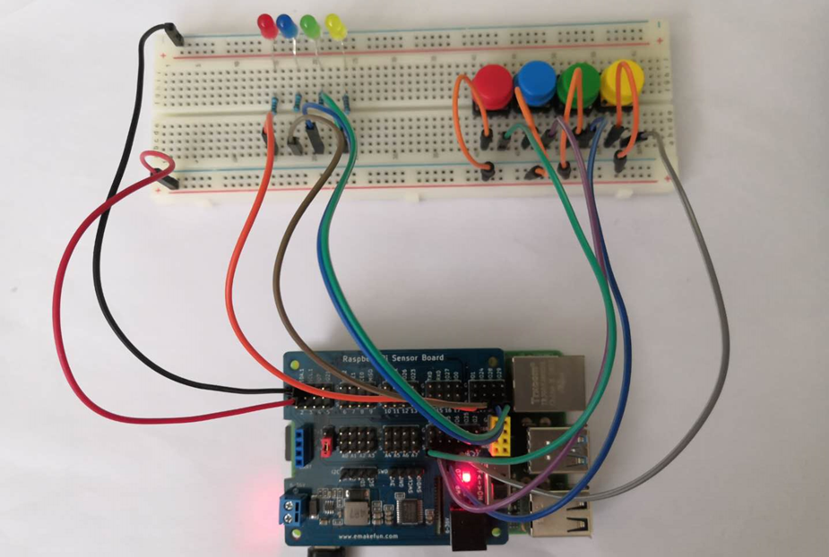

In this experiment, we use the Raspberry Pi to control the four buttons to indirectly control the on and off of the LED to realize the function of four routes calling implement.